

**ASSIGNMENT -4**

**COURSE: DevOps Name: K. MONIKA**

**MODULE: Terraform Gmail: monikakudithetti@gmail.com**

**TRAINER: Mr. Madhukar sir Batch no: 120 - 5pm**

**Date: 15-04-24**

**Creating multiple ec2 instances at a time with different names.**

* Create ec2 instance with any name using Ubuntu-AMI and a key-pair.

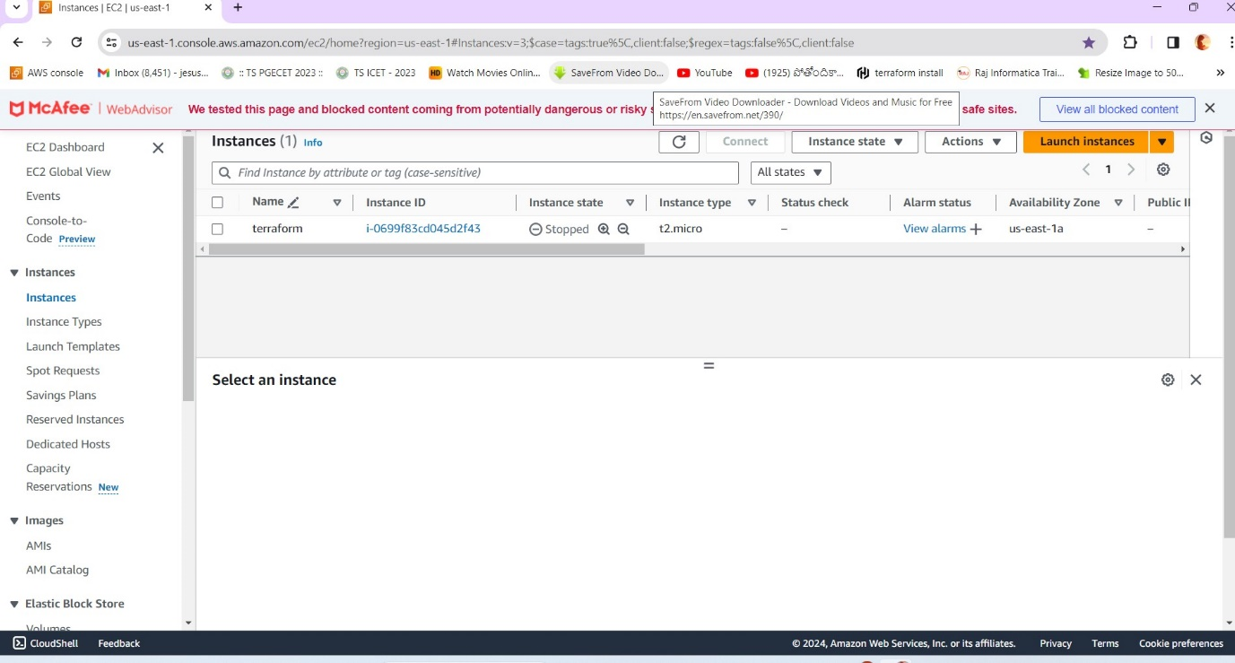

* Connect the ec2 instance, update ubuntu ,install awscli and terraform.

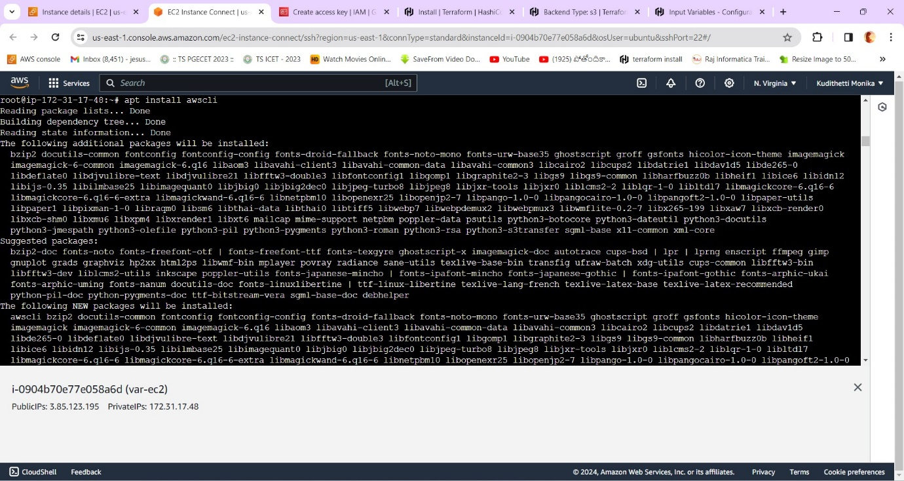

* Create a directory with ‘terraform’ and enter into it. Create a file with a name provider.tf and enter the region, provider in it.

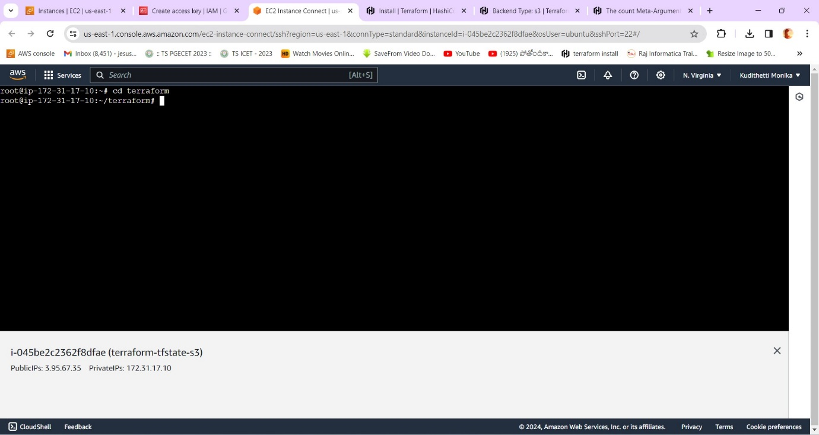

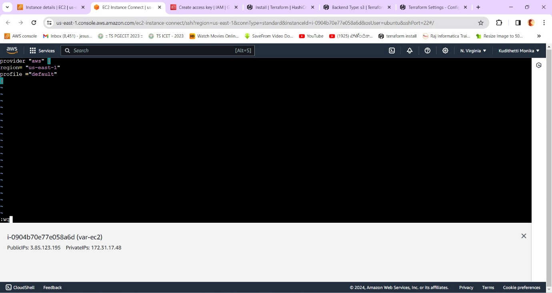

* And create a resource.tf file with count , instance_type , ami and tags.(remove the quotation marks at name -rectified the error later)

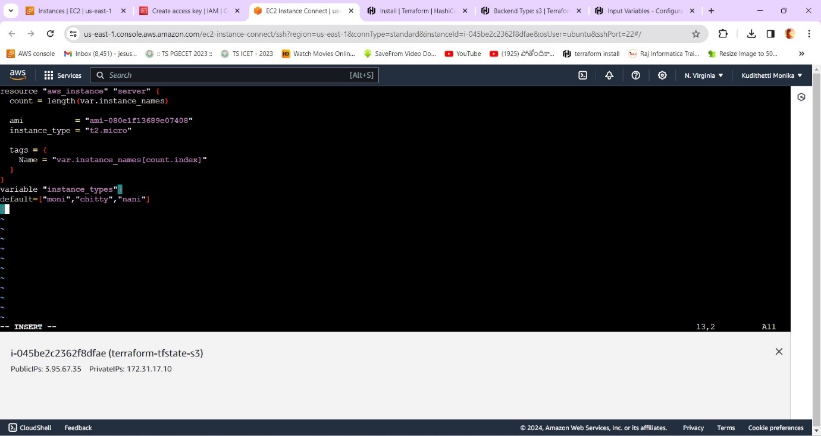

* Create a variable.tf for default instance_names declared at ‘count’ in resource.tf

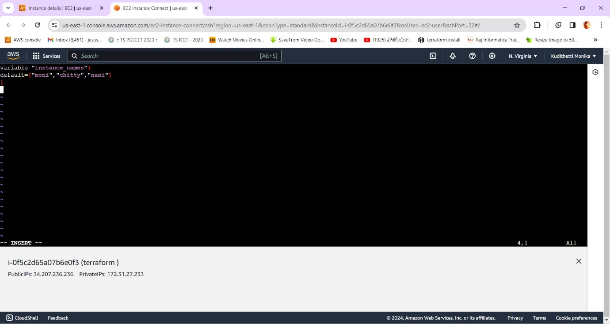

* Finally give the commands terraform init,terraform valid and terraform apply for the initialization of terraform code,validating the code and launching the ec2 instances respectively.

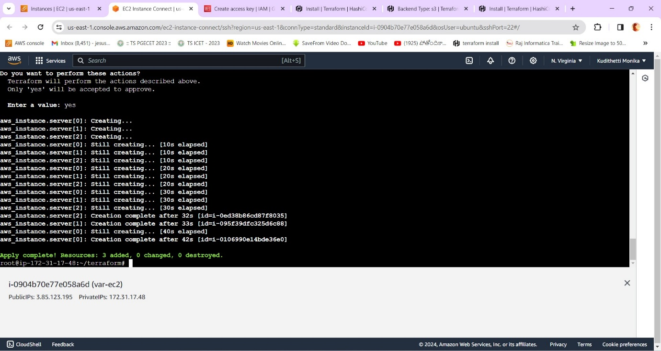

* Finally the instances have been created successfully.

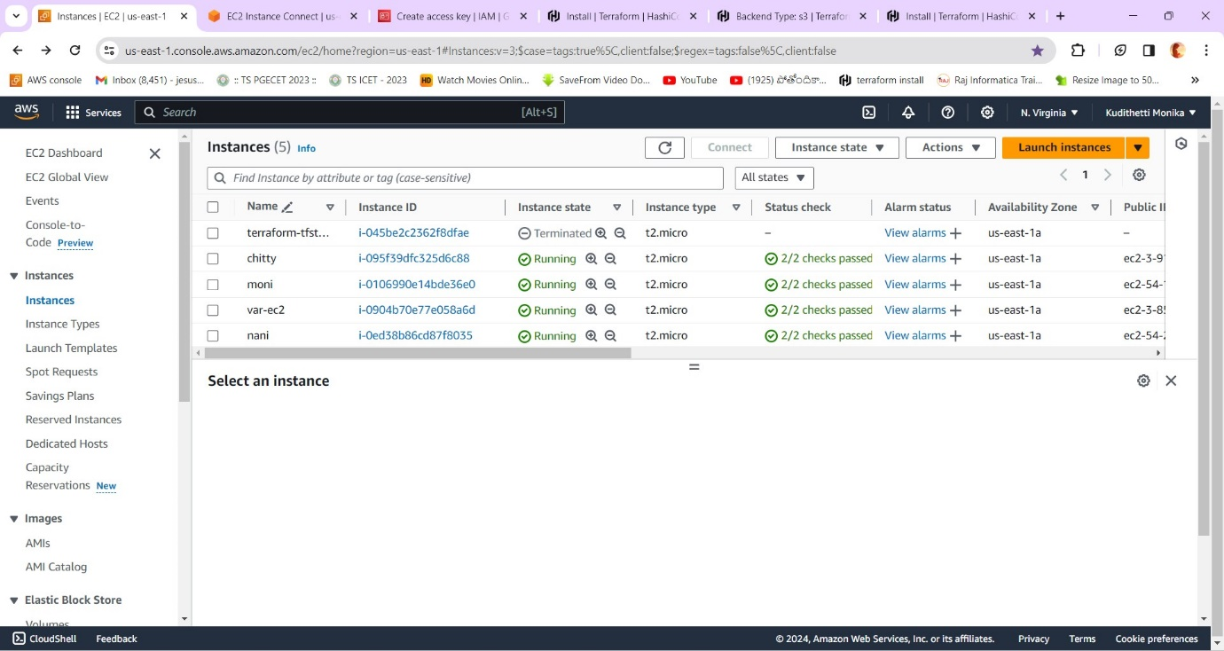

* The instances have been verified in AWS console successfully.